**Final project proposal**

**Students**

*Bolous Abu-Jaber 200769149*

*Ahdab Serhan 203623624*

**Instructor**

*Dr. Miri Weiss-Cohen*

**General Idea**

We are looking to use state of the art technology in Computer Vision(Perception), together with Arduino based robotics, in order to implement a high-level robust framework for a Multi agent system of robots cooperating together to solve various tasks.

**Specific problem**

One specific problem we want to focus on is the ability to autonomously scan buildings (SLAM), and create a 3D map, as well as detect humans, create a heat-map of the area…, This is useful especially in emergency situations (Fire, Earthquakes…), the system could be deployed first in order to map the area and give a better estimation on the situation.

**Implementation**

We are looking to use Intel’s Euclid, a 3D depth camera equipped with an IMU, Quad-core processor and Ubuntu Linux, the device will be used to continuously scan the environment, provide ‘vision’ and serve as the main development platform, we are planning to use ROS as a framework.

For robotics, we will use a simple Arduino based differential drive robot, with wheel encoders and IR sensors, each robot will be able to navigate through a dynamic environment, while focusing on 3 main goals (Avoid collisions, minimize cost, minimize time) and together they will cooperate in order to reach a common goal and optimize solving the task.

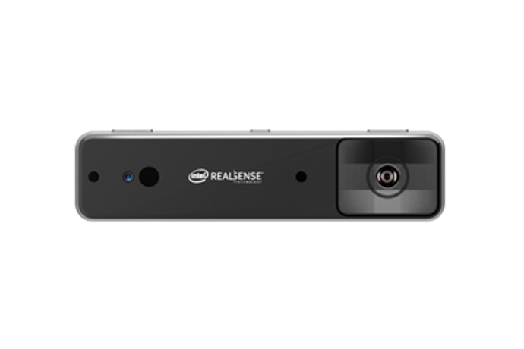

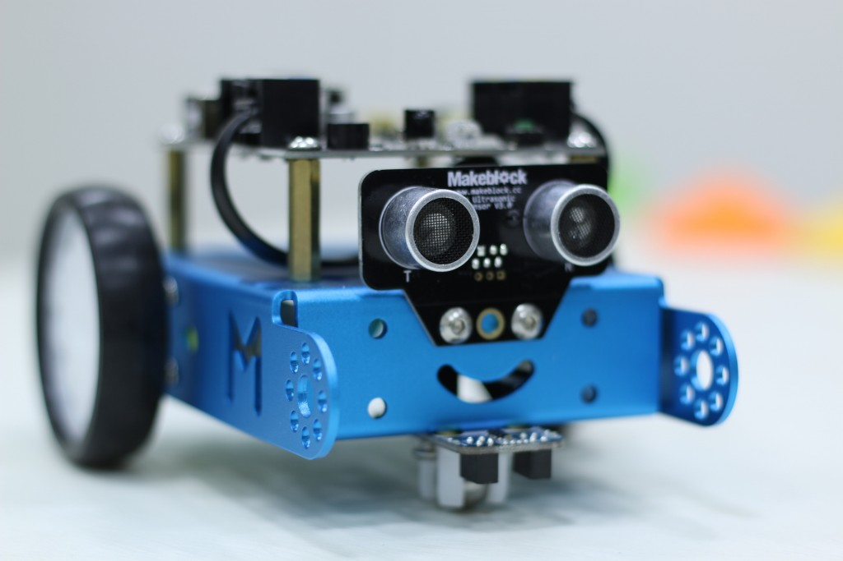

mBot(right), Euclid(left)